**Chocoholics Anonymous**



***Use Case Specification Document***

**04**

**Report Extraction**

**Version No. 2.0**

**Project Document Revision History**

|  |  |  |  |
| --- | --- | --- | --- |
| **VersionNumber** | **Date** | **Revision Author** | **Description of Revision** |
| 1 | 06/11/2019 | Kopal Shinde | Initial Version |
| 2 | 07/17/2019 | Hristo Bonev | Making revisions as needed. |

|  |
| --- |
| **Table of Contents** |

1. Introduction 4

2. Use Case Information 5

2.1 Actors 4

2.2 Use Case Interaction 4

3. Trigger 6

4. Pre-condition(s) 6

5. Post-condition(s) 6

6. Use Case Swimlane (Activity) Diagram 7

7. Main/Basic Flow(s) of Events (Happy Path) 8

8. Alternate/Exception Flow of Events 9

9. Assumptions/Business Rules including Non-Functional Requirements 10

10. Use Case Specification Review and Signoff 10

# Introduction

This use case provides the specification for the report extraction feature. ~~The report can be requested by the manager at any point of time. Different versions of report are produced depending on for whom it is dedicated.~~ The manager can request the summary report at any time from the data center services. The manager’s summary report contains a list of all the providers to be paid, number of consultations each had, and his or her total fee for that week. The report should also contain information on the total number of providers who provided services, the total number of consultations, and the total fee to be paid.   
 Each provider who has billed ChocAn during that week receives a report via email for the list of services provided by them to ChocAn members and the weekly fees. The report should also contain the total number of consultations with members and the total fee for the given week.   
 Each member who has consulted a ChocAn provider during that week will receive a report having details about the weekly services they received and the total cost of the services rendered through email.

~~The manager will receive the Summary Report which contains a list of all the providers to be paid, number of consultations, and total fee for the specific week. The provider and member receives the report on a weekly basis through email. The Provider report is generated for the provider which contains the list of services provided by them to the members and the total fees for the week. The Member Report is generated for the member which contains the details of services received by them for the week and total cost of the services.~~

# **Use Case Information**

## Actors

An actor is someone or something (e.g. application system) outside the system or business that interacts with the application. For every Use Case, there must be at least one Main Actor and zero or more Secondary Actors. Actors should be a person, system, or time.

|  |  |  |
| --- | --- | --- |
| **Actor Name** | **Role** | **Description** |
| System | Main | The system generates different reports. |
| Manager | Main | Manager is having the right to request a report at any time. |
| Provider | Secondary | Provider gets the report through email from the system on a weekly basis |
| Member | Secondary | Member gets the report through email from the system on a weekly basis |
| Time | Secondary | The batch process runs every Friday at midnight |

## **Use Case Interaction**

**Predecessors :**

Manage Members ~~Registration~~ - use case ID-01 - A member must be registered with ChocAn Data Center to take the services, so that the system generates a report based on that.

Member Payment -use case ID - 03 - The member payment reflects the member status in the system which is tracked in the report.

~~Provide~~Track Service - use case ID-05 - Once the services are provided by the provider to the members, the report gets generated by the system weekly and also the summary is extracted by the Manager.

**Successors :**

Provider Payment - Use case ID-02 - After the report is extracted for the provider, the report is used by the provider payment use case to process payment transfer.

# **Trigger(s)**

**3.1** Time triggers the weekly report generation process every friday at midnight.

**3.2** The manager is capable of requesting a report at any given time. ~~manager triggers the report extraction any time.~~

# **Pre-condition(s)**

Below are the pre-conditions which must be met before report extraction.

* 1. A member must be registered with ChocAn Data Center to avail the services.
  2. A member must have received a service from a provider during the week in order to receive an email.
  3. A provider must have provided a service(s) to a ChocAn member during the week in order to receive an email. ~~Provider must provide the services to the members.~~
  4. Member status must be updated by the Member Payment use case to reflect the current status in the system.

# **Post-condition(s)**

Below are the post-conditions which must be met after the report is generated.

* 1. All reports have been successfully generated and sent out to their corresponding users.  
     ~~Payment process must be initiated by using the provider report which displays the provider id and total amount to be payed to the provider.~~

# **Use Case Swimlane (Activity) Diagram [**Diagram below was deleted**]**

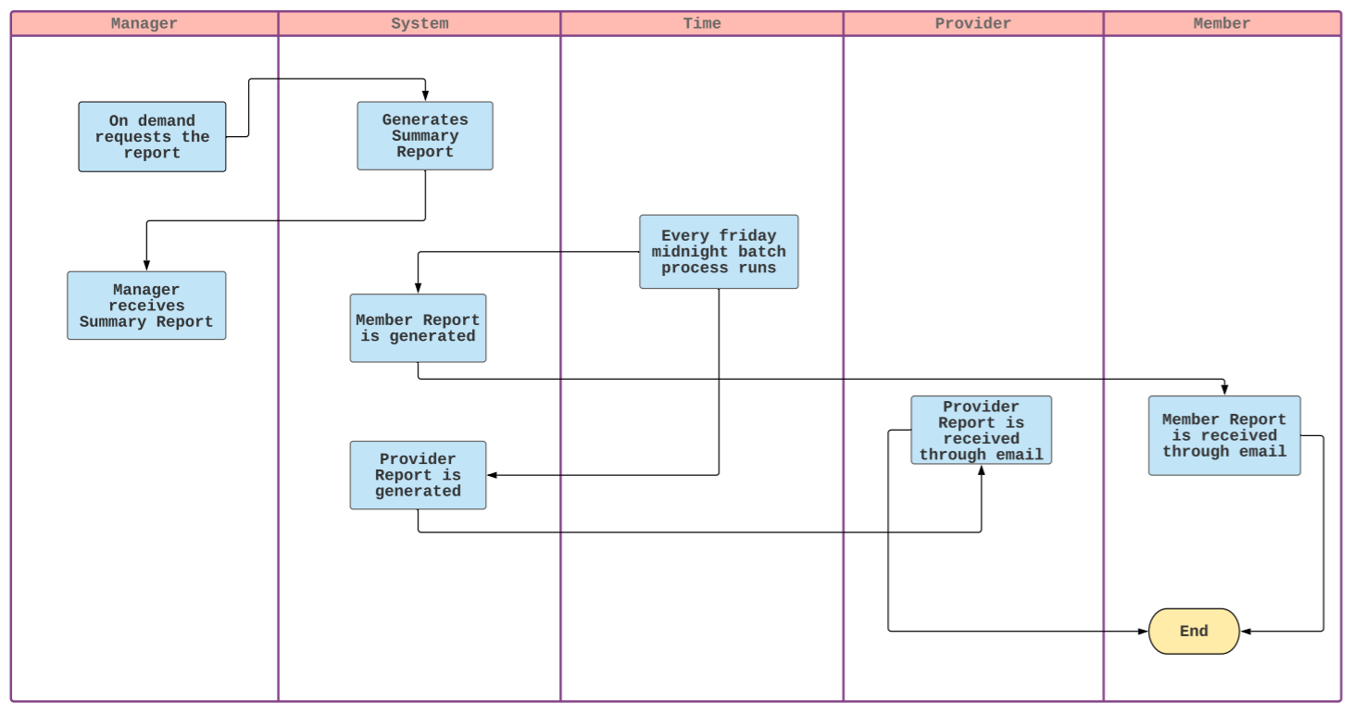

# **Main/Basic Flow(s) of Events (Happy Path)**

* 1. The System request the current day and time from the Time actor.
  2. The Time actor provides the current day and time
  3. If it is Friday 12:00 am:
     1. The system generates the member, provider, and manager reports.
     2. After generating the reports, all reports are sent out to their respective users.
  4. If NOT Friday 12:00am:
     1. The system will check if the user is requesting a summary report
     2. If so, the system will check if the user is a manager.
     3. If a manager is requesting the report, the report is generated and sent out to the manager.
  5. ~~Manager receives the Summary Report:~~

1. ~~The report is requested by Manager at any time.~~
2. ~~The system generates the Summary Report at any time.~~
3. ~~The manager receives the Summary Report.~~

**~~7.2~~** ~~Provider receives the Provider Report:~~

1. ~~The reports are generated weekly having the details on service provided by the provider and fees.~~
2. ~~The provider report is sent as an email to the provider.~~

**~~7.3~~** ~~Provider receives the Member Report:~~

~~1. The reports are generated weekly having the details on service received by the member and fees.~~

~~2. The member report is sent as an email to the member.~~

# **Alternate/Exception Flow of Events**

* 1. The day/Time return process fails to run.
  2. User attempts to access report without having manager status.
  3. ~~There can be null data in the System.~~
  4. ~~The batch return process fails to run.~~
  5. ~~System gives error in report extraction due to null data in System.~~

# **Assumptions/Business Rules including Non-Functional Requirements**

None

# **Use Case Specification Review and Signoff**

|  |  |  |  |  |
| --- | --- | --- | --- | --- |
| **Review and Signoff of the Use Case Specification** | | | | |
| **Name** | **Project Team Role** | **Signature** | **Date** | |
| Tejaswi Dasyam | Team Member | tejaswi | 06/11/2019 | |
| Vaishali Jain | Team member | vaishalijain | 06/11/2019 | |
| Khushmeet Kaur | Team member | khushmeetkaur | 06/11/2019 | |
| Mohanapriya Kottan Rajaraman | Team member | Mohanapriya | 06/11/2019 | |
| Kopal Shinde | Team Lead | kopal | 06/11/2019 | |
| Zaid Alsafi | Team member |  | 07/18/2019 | |
| Maxx Achtman | Team member |  | 07/18/2019 | |
| Hristo Bonev | Team member | Hrsto | 07/18/2019 | |
| JessRose Narsinghia | Team member |  | 07/18/2019 | |

# 